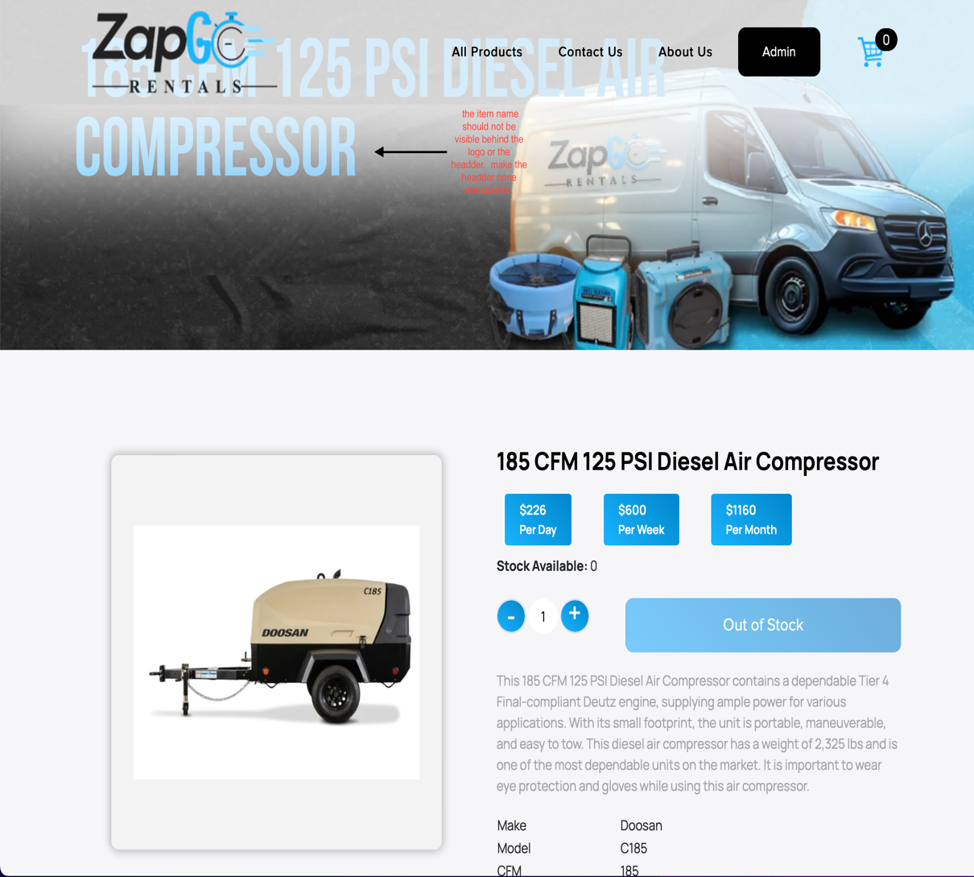

1. Make the header none transparent and the item name need to be below the header. The visual don’t look good. That’s how it appears on my computer.
2. 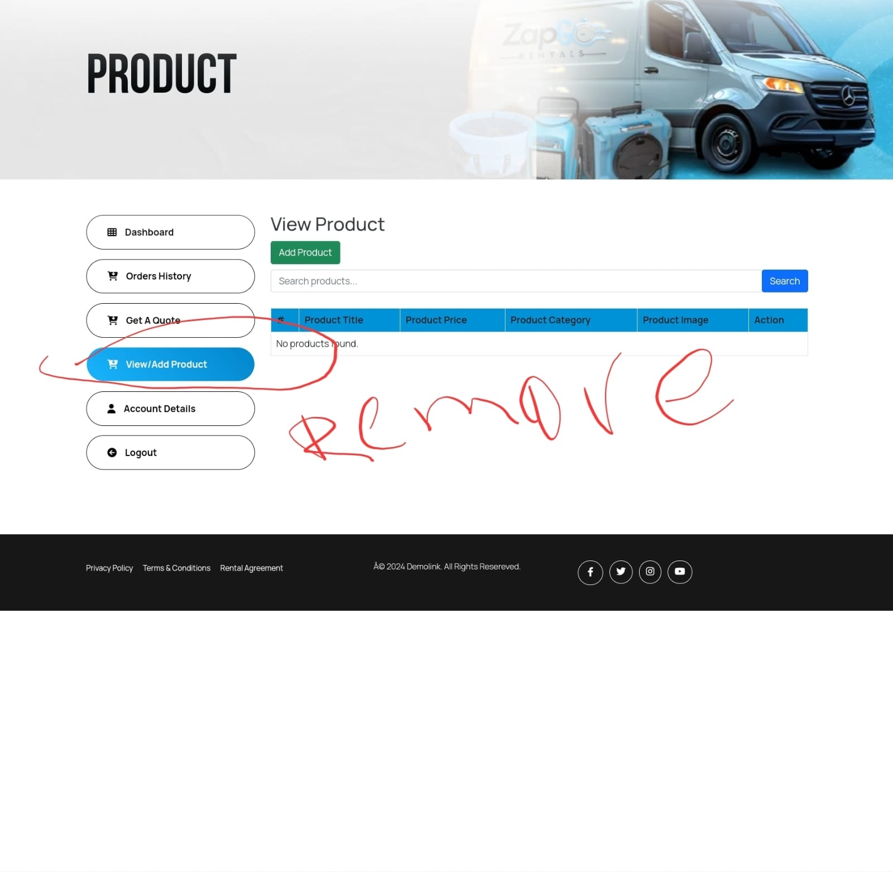

Remove view/add product from the customer dashboard.

1. What would the customer receipt look like?
2. privacy-policy, terms and conditions and rental agreement needs to be done.
3. Employer access needs to be done.
4. In the shopping chart, when I adjust the quantity up or down the price doesn’t reflect correctly.